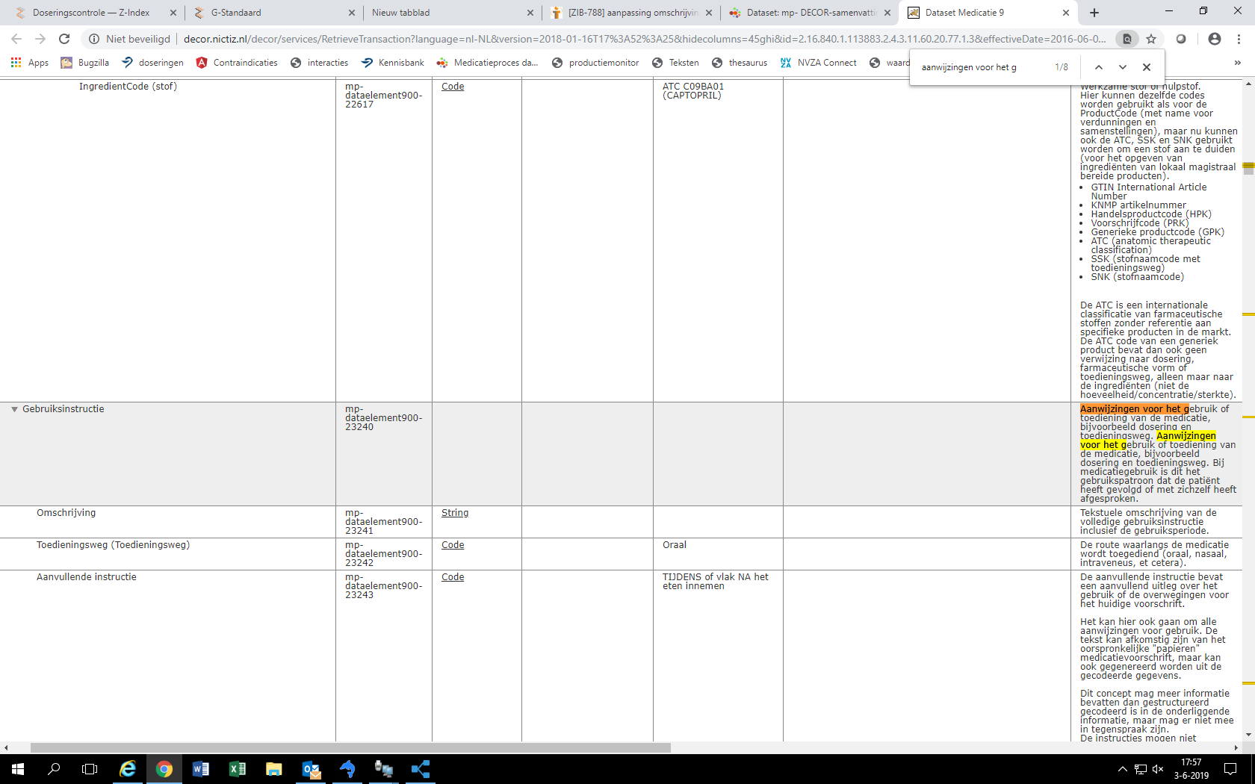

http://decor.nictiz.nl/decor/services/RetrieveTransaction?language=nl-NL&version=2018-01-16T17%3A52%3A25&hidecolumns=45ghi&id=2.16.840.1.113883.2.4.3.11.60.20.77.1.3&effectiveDate=2016-06-01T00%3A00%3A00&format=html

